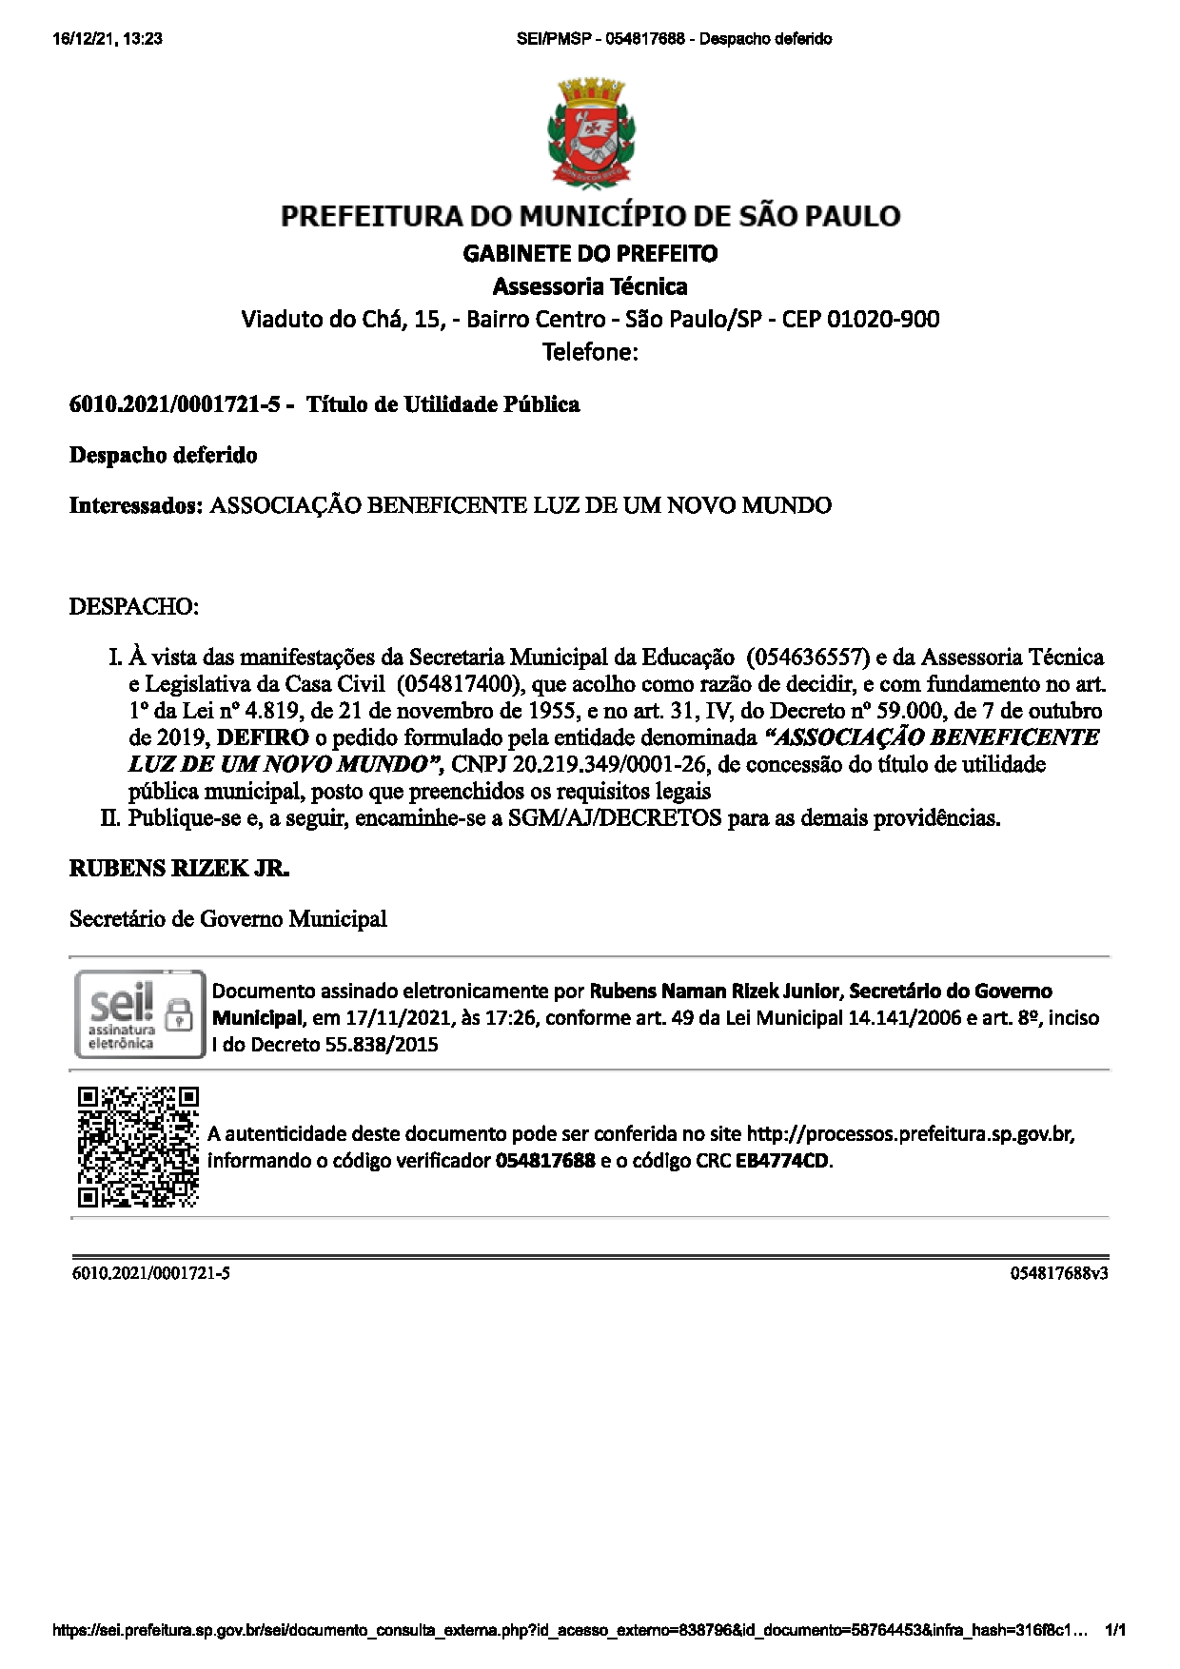
01232040676 03 3 89fffi8ffffi,-.0/1..0123416781987
2 1

/012454789:4;428
3 5
0<<=<<>?@5BCD@A AC
EFHIJHKMNOPQRPSTGFUMVWJKSXYKZGI[\XZSM]Z^Q^_^S^^
GK
UK U
K
`
aV[bWVc VK
defegehfieefjhfkkoprsuvwqsuyuvz{|s}y
h e l qt xx x
~v€y}tuv‚ƒxt vu
„…qƒvyut†‡ˆˆ‰Š‹Œ‰Ž‘‹’“”•–”—‰˜‰—”–‰
v ‡ Š

•ˆ™‡Šš‰›
‹“§ ¡ ®¢ ¤¢¥Ÿ§ ¡¨©§ ®¢²³´»§¡´Ÿ²—½¬¥ŸŸª¢®£¢°¤ª¢¨¯°°²³´µ¶µ³³·¸§°¤‡¬ § °«¥¡¹ª¥Ÿ«œ
œ§žŸŸ£¡ž¢£¢Š¢ ¢ŠŸŸ£±ˆ§ª«¼·«²¸¾¬§¢°®°ª£¬°«À¯±£§£§ªŸŸ½§ª£¢¦ ¥£¢¤§¢’¥°¢¢
¢¢Ÿ ¦ ¢ ž ¢¢ ª ¿ Ÿ° ª¡
¼Á£¢“Â½~Á´œ¼Â½£§§££§¥°ž§¤Ä«°£§®Â³³½§¢£§¢«§¥°¤Ÿ˜¢£¢ÉÊ§ª«Ì£Í«Ê³Âœ²²½£§ÓÕ§°¬¡Ä« º§Ÿ¥ » Ã¼
£§Ã²¼ÓØÅÆ„ÇÈ°ÛØŸÔ°¦«Þ¬®£ßÃ²œ¼Âœ´Âà²²œáµ‹£§ª°¥ª§ ¯°Î°¡¡Ì°£§¬¡®£¢£§¬ °
° §¼¢§¥¡£¥°£¡¶¼½¢½£°–ËË§¡¥ÁÏÐ²ÒÓÔ·£ÎÍÓÔÖÓ °
£Ú°ÝŠ¢™ Ã Ÿ ² ¼Ã½
¤ •
×ãÄ®ª¢¤¬ÛŸÔÌ®° ¡¾¬§Ì«§¥ª¿Ÿ° ° «¾¶ŸŸ° ®º¢Ÿ ÙŸ ¥ªŸ Ü ° §
‹œ™¬ Ÿ ¢
‹¾ ØÄ®Ú¬§á§§½¢§ºÌŸ½§¥ª¢¤¥¿§á§£ˆä—àßà Šå§’‰ ¢«¢ £§¤¢Ÿâ°žŸæ¥ªŸŸŸ
ÇwçÅèéÇ„êÅëìÇg
½¬« Ÿ ¢ §¬–¡  ˆ ¢ £ «¬®£ ¢ œ ‡
ˆ§ª«¡«°£§ä°ž§«°—¬¥ŸŸ¢®
§íŸ • ª

îKïI@@WJVGññF1GHK\_VJQP2ïGðVWJïòKU:óô=D<35`HG6V@=÷øFF>GPù=C?=ú\?@^3>V/GUý48DPFïFK
ðVA0KðQW\QQV[_UWFQ1c3PKWbUðVGUJAõAD:F7IWD@?Q545Qû_>ü >J=?9>Wñ
þHóDîCÿUPRR4ff8\_^^R
K ñ _V K 4
ö óïò[ Q ^
K VïVJ 8 Q K

FbUð
fiGIJWïFGHï/HVñJ-HKFIðHKUK23416ñVUïKWbUFFKK8FVNffiòc397KïVññKñ4UbFIU4ò4K-4U
WK
VGWHKKVHFKVVUïïGVWJ1òKHV744VKV/HGWMñM41366\\òU4 òVVJGñ, .P

µ²¼²œ²Ã¼à²²¼·Ã¼á Ã² ³
H,0
ï
H, J

²³´»¼·µ»»ž¶

63272139!23"7#$21871!%1&'17&2!(4'1)4363*'411227'1)7+.6./,1-'871!%1&+,./1--,6-94'6426+601910. 02
22 114 22 7 1& 8 1& 8 7 & . 0

